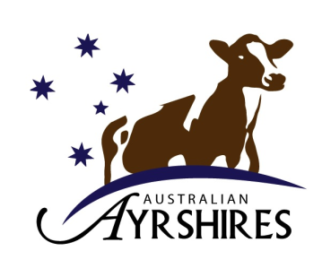
Australian Ayrshires
2024 NATIONAL PRODUCTION CHALLENGE

ENTRY FORM AND RULES
DETAILS

- The National Test Challenge is open to Ayrshire Cattle registered in the full Herd Book section, and section R1. – All animals must be registered prior to entry
- These competitions are for lactations not exceeding 305 day period completed between 1/7/23 & 30/6/24 - (CALVED On or AFTER 31ST AUGUST 2022)
- Figures required are for a 305 day lactation period or less.
- Owner sampling figures are acceptable, but this fact must be stated on the entry form.
- Certificates and Prize money will be awarded. Highest milk production will be awarded certificates for sections C, D, E, F and G. – Awards will be presented at the 2024 IDW Dinner

SECTIONS

A. HERD AVERAGE - Highest Total Butterfat + Protein. (2-10 cows,11-50 cows, 51 cows & over)

B. TEAM OF TEN (10) COWS - Highest Total Butterfat + Protein.

C. COW 2 YEARS (30 mths and under at calving) - Highest Total Butterfat + Protein.

D. COW 3 YEARS (31 mths to 42mths at calving) - Highest Total Butterfat + Protein
E. COW 4 to 6 YEARS (43mths to 78mths at calving) - Highest Total Butterfat + Protein
F. COW 7 to 9 YEARS (79 mths to 114mths at calving) – Highest Butterfat + Protein

G. COW 10 YEARS AND OVER (115 mths and over at calving) - Highest Total Bfat + Protein

The figures entered into the competition are from: (circle one)

1. Official recording 2. Group recording 3. Owner sampling herd recording system

MEMBER'S NAME:
STUD NAME:
ADDRESS:
………………………………………………………….. TELEPHONE:
All entries close 29th November 2024

Return entry form to:
Australian Ayrshires
PO Box 189, Kiama NSW 2533
Email: anne@lbcentre.com.au

2024 NATIONAL PRODUCTION CHALLENGE ENTRY FORM

SECTION A: HERD AVERAGE (305 day records or less) All recorded cows must be included.
Herd sizes: 2-10 cows, 11-50 cows, 51 cows & over

Number of Cows: ______ Litres: ______ Fat%: _____ KG: ______ Prot%: ______ KG: _____

SECTION B: TEAM OF TEN (10) COWS (305 day records only please)
* All individual Cows must be registered prior to entry

 | Name of Cow | Herd book no. | Calving date | Protein kgs | B’fat kgs | Total Protein and B’fat kgs
1
2
3
4
5
6
7
8
9
10
 | Total Protein and Butterfat kgs for 10 cows

SectionS: C, D, E, F & G (fill in all information)
* All individual Cows must be registered prior to entry

Section | Name of Cow | Herd book no. | Date of birth | Calving date | Protein kgs | B’fat kgs | Total Protein and B’fat kgs | Litres of Milk produced
C
C
C
D
D
D
E
E
E
F
F

F
G
G
G

