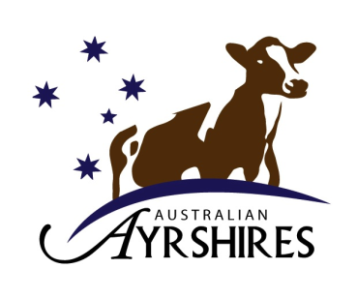

Australian Ayrshires

2024 Cow of the Year

ENTRY FORM

The Ayrshire Cow of the Year Competition is open to Ayrshire Cattle registered in the full Herd Book section, Appendix A & B and section R1. (Min 75%)

Please complete the following details clearly:

Cow’s name

Registration No ………………………………. Herd Recording No

Classification score: …………………… x 100 = …………………
(Must be VG or above)
Lactation Yield (milk): …………………… x 1 = …………………
(305 day records only)
Lactation Yield (protein): …………………… x 20 = …………………
(305 day records only)
Lactation Yield (B’fat): …………………… x 10 = …………………
(305 day records only)

Royal Show Champion (Achieved in 2022) x 500 = …………………

Royal Show Res Champion (Achieved in 2022) x 250 = …………………

IDW Champion (Achieved in 2022) x 1000 = …………………

IDW Res Champion (Achieved in 2022) x 750 = …………………

TOTAL

Date of completion of 305 day lactation period

NOTE: Lactation must be most recent, and 305 days completed between
1/7/23 & 30/6/24
All entries must be accompanied with a copy of the animal’s latest production certificate

Owner's Name:
Address:
Stud: ..................................................................... Phone no: ………………………………
All entries close: COB 29th November 2024

Return this form to:
Australian Ayrshires,
PO Box 189, Kiama NSW 2533
Or email: anne@lbcentre.com.au

