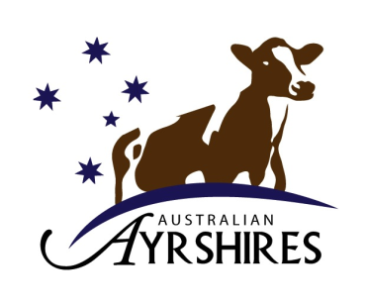
Australian Ayrshires
2024 All Australian Photo Competition

ENTRY FORM

Owner: ______________________________________________________________

Address: ______________________________________________________________

Phone: _______________________ Signature: ___________________________

Entry fee of $5.50 inc GST to be paid with entry (no invoice will be sent). Entry will not be accepted until entry fee is paid.
Classes:
(For all classes the age of the animal is the age at the time the photo was taken)
Class 1. Heifer dry 6 months and under
Class 2 Heifer dry 12 months and under
Class 3 Heifer dry 18 months and under
Class 4. Heifer dry 24 months and under
Class 5. Heifer under 36 months dry (NB There is no class for this in the World Competition)
Class 6. Heifer 2 years old in milk
Class 7. Cow 3 years
Class 8. Cow 4 years
Class 9. Cow 5 years
Class 10. Cow 6 and 7 years
Class 11. Cow 8 years and over
Class 12. All Australian Youth class
Class 13. Ayrshire unhaltered
Class 14. Herd Scene
Class 15. Character shot

Class entered: _____ Name of Animal: _________________________________________________________

Date of Birth: _________ Herd Book No __________Photograph date ____________ Photo No___________

Class entered: _____ Name of Animal: _________________________________________________________

Date of Birth: _________ Herd Book No___________Photograph date __________ Photo No ____________

Class entered: _____ Name of Animal: ________________________________________________________

Date of Birth: _________ Herd Book No___________Photograph date ___________Photo No ____________

Class entered: _____ Name of Animal: ________________________________________________________

Date of Birth: _________ Herd Book No___________Photograph date __________ Photo No ____________
_________________________________________________________________________________________

Class entered: _____ Name of Animal: ________________________________________________________

Date of Birth: _________ Herd Book No___________Photograph date__________ Photo No ____________
________________________________________________________________________________________

Class entered: _____ Name of Animal: ________________________________________________________

Date of Birth: _________ Herd Book No___________Photograph date__________ Photo No_____________

Class entered: _____ Name of Animal: _________________________________________________________

Date of Birth: _________ Herd Book No___________ Photograph date__________ Photo No_____________

Class entered: _____ Name of Animal: ________________________________________________________

Date of Birth: _________ Herd Book No___________Photograph date _________ Photo No ____________

Class entered: _____ Name of Animal: ________________________________________________________

Date of Birth: _________ Herd Book No___________Photograph date__________ Photo No ____________

Class entered: _____ Name of Animal: ________________________________________________________

Date of Birth: _________ Herd Book No___________Photograph date___________ Photo No___________

Class entered: _____ Name of Animal: ________________________________________________________

Date of Birth: _________ Herd Book No___________Photograph date____________ Photo No__________

Class entered: _____ Name of Animal: ________________________________________________________

Date of Birth: _________ Herd Book No___________Photograph date____________ Photo No__________

Class entered: _____ Name of Animal: ________________________________________________________

Date of Birth: _________ Herd Book No___________Photograph date____________ Photo No__________

Youth Class entry - Name of Leader: ______________________________ Date of Birth _____________

Name of Animal: _______________________________________ Date of Birth: ______________

Qualifying show and date: __________________________________________________________

Name of owner of exhibit: __________________________________________________________

ENTRIES CLOSE: COB Friday 29th November 2024 with the Federal Secretary

